SDCSS Scholarship

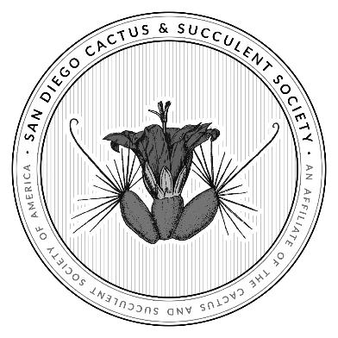Introduction

The San Diego Cactus & Succulent Society (SDCSS) is a 501(c)3, non-profit organization whose mission is to promote knowledge, study, and interest in cactus and succulent plants through educational programs, public exhibits, a public garden, and sharing of this common interest. Through this scholarship, we hope to support and encourage outstanding students who are pursuing higher education in horticulture, botany or plant science and whose goals are aligned with that of the SDCCS.

Overview

Our Scholarship Program is for high school, or college/university students who are residents of San Diego County and who have shown an interest in pursuing a degree in horticulture, botany or plant science.

Current Scholarships

SDCSS will award at least one $1,000 scholarship each year.

Applicants are asked to submit one single application. All applications received will be judged by the San Diego Cactus & Succulent Society Board of Directors. Only applicants who have not previously been awarded an SDCSS scholarship may apply.

Requirements

Applicants must complete the attached San Diego Cactus & Society Scholarship Application in addition to providing the following (see application for details):

* Two references, one of which should be academically related. The other may be a professional or personal reference by someone unrelated to you.
* A copy of your most recent grade report showing current semester/quarter GPA and cumulative GPA
* A one-page essay telling us about yourself. Please include answers to the five questions listed on the application.

Submission Deadline

The application period is from April 1 to May 15. Completed applications must be submitted by email to sdcssbusinessmanger@gmail.com. no later than May 15

Awards

The SDCSS Scholarship Committee will meet to evaluate the submissions before the Board of Directors meeting in June and present their recommendations. All applicants will be notified by email shortly after the board has made their decision. The prevailing recipient will be honored at an SDCSS General Meeting in July. The check will be made payable to the applicant for the use of fees, textbooks or other educational expenses. Recipients will also receive a one-year membership to SDCSS. All decisions made by the SDCSS Board are final